|  |  |
| --- | --- |
|  | Information Technology Department - State Polytechnic of Malang  **Jobsheet-05: PHP 2**  **Course: Web Programming / Web Design and Programming**  Instructor: Web Design and Programming Teaching Team  *September 2024* |

**Topics**

1. Concept of *arrays* in PHP programming
2. Concept of *functionss* in PHP programming

**Objective**

Students are expected to:

1. Understand the concept of arrays in PHP programming
2. Understand the concept of functions in PHP programming

**INTRODUCTION**

**Introduction to Arrays and Functions**

Arrays and functions are fundamental concepts in programming that help organize and optimize code.

* **Arrays**

Array, or a list, is one of the data types. An array is not a basic data type like an integer or a boolean, but rather a data type that consists of a collection of other data types. Arrays make it easier to group data, save on writing, and make variable usage more efficient. An array is a data structure that holds a collection of elements, ***usually*** of the same data type, under a single variable. Arrays simplify the handling of large sets of data, allowing multiple values to be stored and accessed easily using an index or key. In PHP, arrays are classified into three types:

* Indexed Arrays: Arrays with numeric indexes.
* Associative Arrays: Arrays with named keys that assign a value to each key.
* Multidimensional Arrays: Arrays that contain other arrays as their elements.
* **Functions**

A function is a block of code designed to perform a specific task, which can be reused multiple times throughout the program. Functions reduce redundancy, make code more readable, and increase efficiency. By breaking down repetitive tasks like database querying or mathematical calculations into functions, the program becomes modular, and maintenance becomes easier.

**Practical Section 1. Indexed Array**

A PHP indexed array is an array where the elements are stored with numeric indexes, starting from 0 by default. Each element in the array is associated with an index number, which is used to access or reference that element.

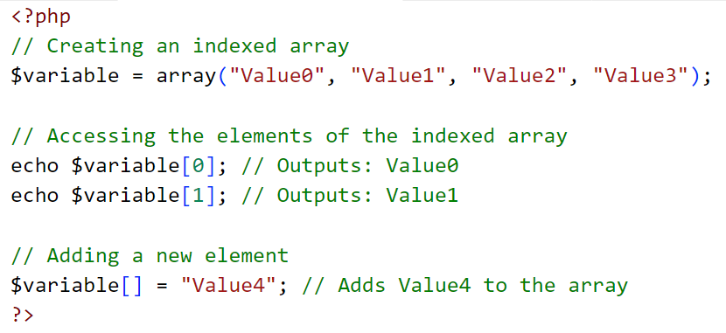

It can also be written as follows:

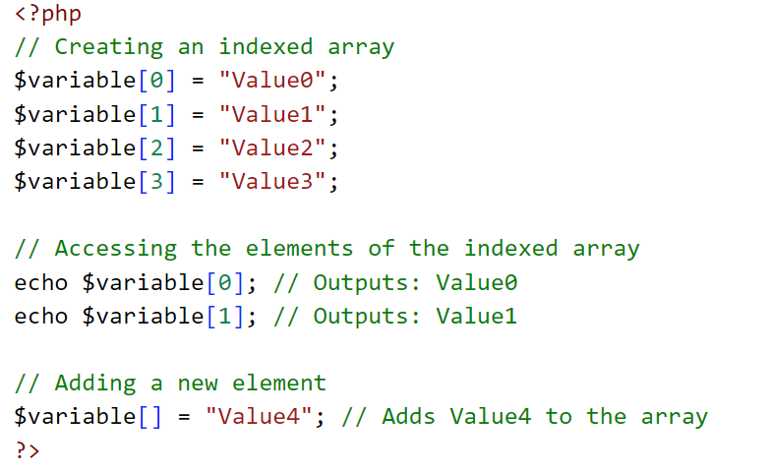

In this form, the array is created by directly assigning values to specific indexes without using the array() function. PHP automatically assigns the next available index if a new element is added without specifying an index, as shown when adding "Value4".

Follow these steps to understand indexed arrays in PHP:

|  |  |
| --- | --- |
| **Step** | **Description** |
| 1 | Create a new file named array_1.php inside the JS05_PHP-2 directory, then type the following code: |
| 2 | Save the file and run your program in the browser. Type this link to your browser  [localhost/dasarWeb/JS05_PHP-2/array_1.php](localhost/dasarWeb/JS05_PHP-Array/array_1.php) |
| 3 | Observe the output displayed |
| 4 | To display an array, in addition to using indexes, we can also use loops. Try displaying the output of the program above using a ***loop***.  (Question No.1) |

**Practical Section 2. Associative Array**

A PHP associative array is an array where the keys are not numeric but instead are strings, allowing you to associate specific values with meaningful keys. This makes it easier to access and manipulate data based on the key name rather than a numerical index.

The components of an associative array consist of key-value pairs. The key indicates the position where the value is stored. PHP uses the arrow symbol (=>) to assign values to keys. Here is the syntax for writing an associative array:

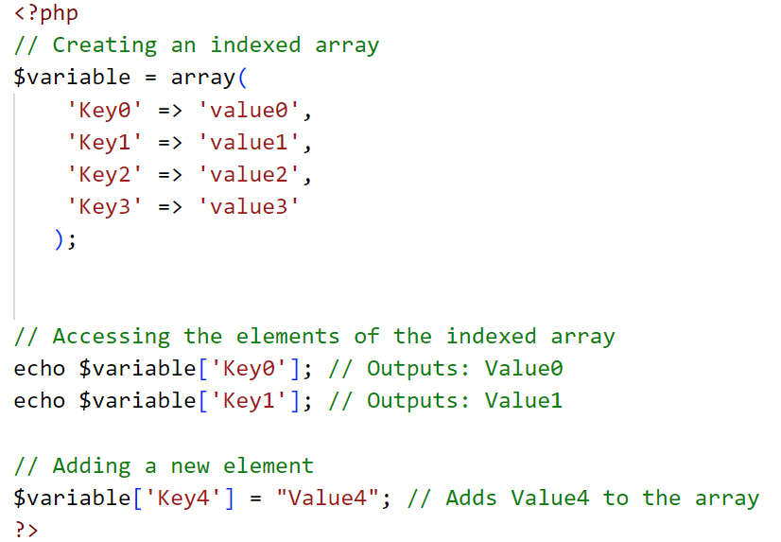

It can also be written as follows:

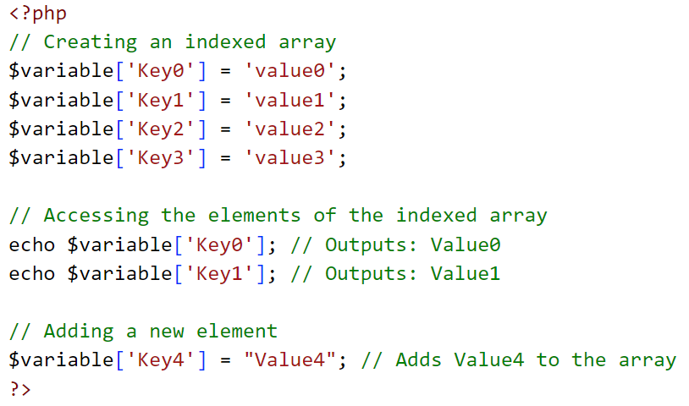

Follow these steps to understand associative arrays in PHP:

|  |  |
| --- | --- |
| **Step** | **Description** |
| 1 | Create a new file named array_2.php inside the JS05_PHP-2 directory, then type the following code: |
| 2 | Save the file and run your program in the browser. Type this link to your browser  [localhost/dasarWeb/JS05_PHP-2/array_2.php](localhost/dasarWeb/JS05_PHP-Array/array_2.php) |
| 3 | Observe the output displayed. Then, add table styling to the output to make it more visually appealing. Here’s the updated code with a simple table style.  (Question No.2)  *For styling, you can choose either internal or external CSS. |

**Practical Section 3. Multidimensional Array**

A multidimensional array in PHP is an array that contains one or more arrays as its elements. This means that each element in the array can be an array itself, allowing you to store data in a grid or matrix-like structure. Multidimensional arrays are often used to represent complex data structures like tables, matrices, or databases.

Example of a Multidimensional Array in PHP:

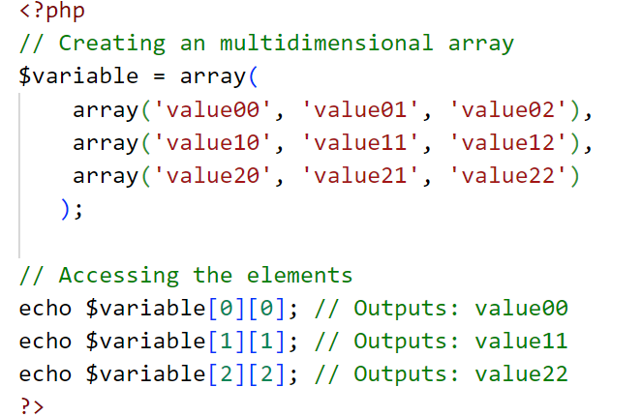

Or it can also be written as follows:

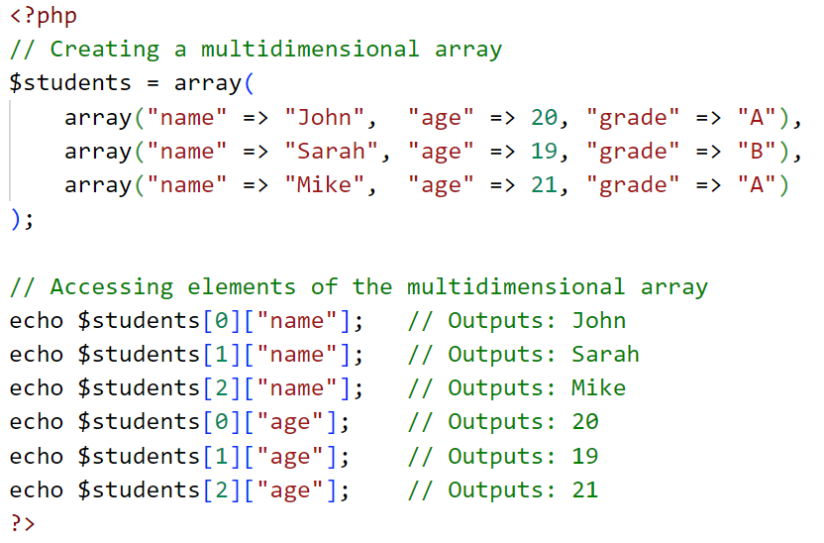

Follow these steps to understand multidimensional arrays in PHP:

|  |  |
| --- | --- |
| **Step** | **Description** |
| 1 | Create a new file named style.css inside the JS05_PHP-2 directory, then type the following code:   |
| 2 | Create a new file named array_3.php inside the JS05_PHP-2 directory, then type the following code:  A screenshot of a computer program  Description automatically generated  A screenshot of a computer program  Description automatically generated |
| 3 | Save the file and run your program in the browser. Type this link to your browser  [localhost/dasarWeb/JS05_PHP-2/array_3.php](localhost/dasarWeb/JS05_PHP-Array/array_3.php) |
| 4 | Observe the output displayed and explain your observations  (Question No 3) |

**Functions**

There are many built-in PHP functions that we often use, such as print(), print_r(), unset(), etc. In addition to these functions, we can also create our own custom functions according to our needs. A function is a set of instructions wrapped in a block. Functions can be reused without having to rewrite the instructions within them. In PHP, a function can be created using the function keyword, followed by the name of the function.

Example:

The instruction code can be written inside curly braces ({...}). Function names in PHP must start with a letter or an underscore and cannot begin with a number. The naming of functions in PHP is not case-sensitive. Follow these steps to understand the usage of functions in PHP:

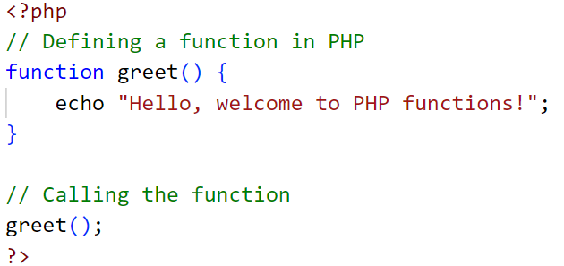

**Practical Section 4. Function**

|  |  |
| --- | --- |
| **Step** | **Description** |
| 1 | Create a new file inside the JS05_PHP-2 directory and name it function.php   |
| 2 | Save the file and run the code. Modify the program so that it can display the output twice. Explain your observations!  (Question No 4) |
| **Function with Parameter** | |
| 3 | To make the instructions inside the function more dynamic, we can use parameters to pass values into the function. These values will be processed within the function.  For example, in the previous function, it's not ideal if the printed name is always "Elok" and the greeting is always "Assalamualaikum."  We can change the person name and the greeting into another words. |
| 4 | Add parameters as in the following program code:   |
| 5 | Observe the output displayed and explain your observations!  (Question No 5) |
| **Function with Parameter and using default value** | |
| 6 | We can assign a ***default*** ***value*** to a parameter. The ***default value*** serves to provide a value for the parameter if it is not supplied.  For example: if we forget to provide a greeting parameter, the program would normally throw an error. Therefore, we need to set a default value to avoid this error. |
| 7 | Write this code to your program   |
| 8 | Observe the output displayed and explain your observations!  (Question No 6) |
| **Function with return value** | |
| 9 | A **function with returns a value** is a function designed to process data and send the result back to the point where it was called. In PHP, you can use the return statement to return a value from a function. This is useful when you need the function to perform a calculation or operation and give the result back to the main program for further use. |
| 10 | Create a new file inside the JS05_PHP-2 directory and name it function_return.php   |
| 11 | Observe the output displayed and explain your observations!  (Question No 7) |
| **Calling a Function Inside Another Function** | |
| 12 | **Calling a Function Inside Another Function** is a common programming practice in PHP and other languages. It allows you to break complex tasks into smaller, reusable pieces by organizing them into separate functions and then calling one function from another. |
| 13 | Modify function_return.php like this code |
| 14 | Observe the output displayed and explain your observations!  (Question No 8) |

**Practical Section 5. Recursive Functions**

**Recursive Function** in PHP is a function that calls itself during its execution. This technique is useful for solving problems that can be divided into smaller, similar subproblems, often referred to as divide and conquer. Recursive functions are typically used to solve problems such as calculating factorials, Fibonacci numbers, and dynamic programming.

|  |  |
| --- | --- |
| **Step** | **Description** |
| 1 | Create a new file named recursive.php inside the JS05_PHP-2 directory, then type the following code:   |
| 2 | If the program code above is executed, what will happen and what would be the impact of doing so? Please share your opinions!  (Question No 9) |
| 3 | To display the numbers 1 to 25, we can easily use a for loop as follows:   |
| 4 | We can create display the number 1 to 25 using recursive function (without for loop).   |
| 5 | Run the program code above and describe its output, then explain why it behaves that way.  (Question No 10) |

**A Multi-Level Menu using Arrays**

A Multi-Level Menu using Arrays in PHP refers to the creation of a hierarchical or nested menu structure where each menu item can have sub-items. This is useful for building navigation menus in websites that have a more complex structure, such as sections with sub-sections or categories with subcategories.

**Example of a Multi-Level Menu using Arrays in PHP:**

To create a multi-level or nested menu structure, arrays can be used to represent the menu items and their sub-items. Here's an example demonstrating how you can use a multidimensional array to create such a menu.

|  |
| --- |
| <?php  // Define a multi-level menu using an associative array  $menu = array(      "Home" => "#home",      "About Us" => array(          "Our Team" => "#team",          "Our Story" => "#story",          "Mission & Vision" => "#mission"      ),      "Services" => array(          "Web Development" => "#web",          "Mobile Development" => "#mobile",          "SEO Optimization" => "#seo"      ),      "Contact" => "#contact"  );  // Function to display the menu  function displayMenu($menu) {      echo "<ul>";      foreach ($menu as $key => $value) {          // Check if the menu item is an array (meaning it has sub-items)          if (is_array($value)) {              echo "<li>$key";              displayMenu($value); // Recursively display the sub-menu              echo "</li>";          } else {              echo "<li><a href='$value'>$key</a></li>";          }      }      echo "</ul>";  }  // Call the function to display the menu  displayMenu($menu);  ?> |

You can try the code above in the file array_menu.php, and run it in the browser.

**Practical Section 6. Multi-Level Menu**

|  |  |
| --- | --- |
| **Step** | **Description** |
| 1 | Create a variable $menu. This variable is a combination of an indexed array and a multidimensional associative array. **It is called multidimensional because it is an array that contains other arrays inside it**. Next, we will try to display all items from the $menu array using a recursive function |
| 2 | Write this code into your multi_menu.php file   |
| 3 | After write code in step 2, write this code after it, to show the menu in browser   |
| 4 | Run the program above and describe the output.  (Question No 11) |
| 5 | Next, make the function above recursive by calling itself when an item from the menu has a subMenu attribute. This will result in a display like the following.  A group of black text  Description automatically generated  (Question No 12) |

**String**

In PHP, strings can be defined using **double quotes (**“ ”**)** or **single quotes (**‘ ’**)**. While both allow you to create string variables, there are important differences in how they handle variables and special characters.

**1. Double Quotes (**" "**):**

* Double quotes allow for **variable interpolation**, meaning that variables within the string will be evaluated and replaced with their values.
* Special characters (escape sequences) like \n (new line) or \t (tab) are recognized and processed.
* **Example:**

|  |
| --- |
| <?php  $name = "John Wick";  echo "Hello, $name!";  // Output: Hello, John!  echo "This is a new line.\nNext line.";  // Output: This is a new line. (moves to next line) |

**2. Single Quotes (**' '**):**

* Single quotes treat the string **literally**, meaning that variables inside the string are not evaluated.
* Escape sequences are not processed, except for \\ (backslash) and \' (single quote).
* **Example:**

|  |
| --- |
| <?php  $name = 'John';  echo 'Hello, $name!';  // Output: Hello, $name!  echo 'This is a new line.\nNext line.';  // Output: This is a new line.\nNext line. |

**Key Differences:**

* **Variable Parsing**: Double quotes will replace variables with their values, while single quotes will display the variable name as plain text.
* **Escape Characters**: Double quotes recognize special escape sequences like \n, \t, while single quotes only recognize \' and \\.

In general, **use double quotes** when you need variable interpolation or special characters. If you don’t need these features, **single quotes** are faster and more efficient for simple string definitions.

Several operations can be performed on string-type data. PHP provides built-in functions that are ready to use for string operations

|  |  |
| --- | --- |
| Function | Description |
| strlen() | To find out the length of a string |
| str_word_count() | To count the number of words in a string |
| strpos() | To find the position of a substring within a string |
| strrev() | To reverse the order of a string |
| strstr() | To search for a substring within a string |
| substr() | To extract a substring from the start to end position within a string |
| trim() | To remove whitespace from the beginning and end of a string |
| ltrim() | To remove whitespace from the beginning of a string |
| rtrim() | To remove whitespace from the end of a string |
| strtoupper() | To convert all characters in a string to uppercase |
| strtolower() | To convert all characters in a string to lowercase |
| str_replace() | To replace parts of a string with another string |
| ucwords() | To capitalize the first letter of each word in a string |
| explode() | To split a string into an array based on a specific character |

***Escape Character***

Special characters that cannot be displayed directly must be preceded by the backslash (\). Strings enclosed in double quotes will replace escape characters with the characters they represent. This is different from strings enclosed in single quotes, where it will simply display the content as-is without replacing anything (with a few exceptions).

The escape characters in PHP are:

|  |  |
| --- | --- |
| **Function** | **Description** |
| \n | New line |
| \r | Carriage-return character |
| \t | Tab character |
| \$ | The $ character itself |
| \" | To display a double quote |
| \\ | To display the backslash (\) itself |

**Practical Section 7. String**

|  |  |
| --- | --- |
| **Step** | **Description** |
| 1 | Create a file named string1.php inside the JS05_PHP-2 directory, then type the following code: |
| 2 | Observe the output displayed and explain your observations.  (Question No 13) |
| ***Escape Character*** | |
| 3 | Create a file named string2.php inside the JS05_PHP-2 directory, then type the following code: |
| 4 | From the program code above, you can observe the difference between double quotes and single quotes in terms of how they handle escape strings. Observe the output and explain the results of each output. What conclusions can you draw from this experiment?  (Question No 14) |
| **Reversing a String using the** strrev() **function** | |
| 5 | Create a file named string3.php inside the JS05_PHP-2 directory, then type the following code: |
| 6 | Observe the output displayed and explain your observations  (Question No 15) |
| 7 | To reverse a string word by word, type the following program code: |
| 8 | Observe the output displayed and explain your observations  (Question No 16) |

**Combining HTML and PHP**

**Combining HTML and PHP** is a common practice in web development where PHP is embedded within HTML to dynamically generate content on a web page. PHP code can be inserted within HTML to process data, handle user input, or display dynamic content.

**Practical Section 8. HTML and PHP**

|  |  |
| --- | --- |
| **Step** | **Description** |
| 1 | The first method is PHP inside HTML. Here's an example code: |
| 2 | The code above is an HTML code that contains PHP code to display the server's date, marked by the tags <?php and ?> |
| 3 | The second method is HTML inside PHP. In PHP, HTML tags are treated as strings enclosed in quotation marks, and various functions can be applied to manipulate strings, such as concatenation, etc. Here's an example of the code snippet: |
| 4 | The code above produces the same output as the previous code snippet. However, the difference lies in the way the code is written, where HTML is inside PHP as a string, and to display it, the echo tag is used. |
| 5 | Which of the two methods do you find easier? Provide your answer along with reasoning.  (Question No 17) |

**HTML Entities**

**HTML Entities** are used to display reserved characters in HTML or characters that have special meanings, such as <, >, and &. These characters must be written as entities to prevent them from being interpreted as HTML code.

Common HTML Entities:

|  |  |  |  |
| --- | --- | --- | --- |
| Entity Name | Entity Number | Description | Result |
| &copy; | &#169; | Copyright | © |
| &reg; | &#174; | Registered | ® |
| - | &#8482; | Trademark | ™ |
| &nbsp; | &#161; | Non-breaking space | ¡ |
| &amp; | &#38; | Ampersand | & |
| &laquo; | &#171; | Left angle quotation | « |
| &raquo; | &#187; | Right angle quotation | » |
| &quot; | &#34; | Double quotation mark | " |
| &apos; | - | Single quotation mark | ' |
| &lt; | &#60; | Less than | < |
| &gt; | &#61; | Greater than | > |
| &times; | &#215; | Multiplication sign | × |
| &divide; | &#247; | Division sign | ÷ |

**Practical Section 9. HTML Entities**

|  |  |
| --- | --- |
| **Step** | **Description** |
| **1** | Create a file named entities.php inside the JS05_PHP-2 directory, then type the following code: |
| **2** | Observe the output displayed and explain your observations  (Question No 18) |

**HTTP *Header***

HTTP headers are data sent between the web browser and the web server as a means of communication between the two. The HTTP header contains information on how to handle the files being sent or requested.

The ***request-response*** cycle for a web page: When we access a web page, the web browser automatically sends an HTTP request to the web server. The HTTP request contains a lot of information, one of which is the HTTP header. In the HTTP header (sent during the request process), there is information about the file being requested (whether it is an HTML file, a PHP file, a PDF file, or something else), as well as additional info such as the type of web browser used, the operating system, and the IP address. Once it reaches the web server, the information in the HTTP header is read, and the web server prepares the requested files. After that, the web server sends those files back to the web browser. This return process is also known as an HTTP response.

HTTP *Header*

This **HTTP response** consists of ***two parts***: ***the HTTP header*** and ***the web file***. **The HTTP header** contains information about the web file being sent, such as the data type, the date it was sent, the name of the web server, and the operating system used by the web server. **The web file** itself consists of the HTML file that makes up the web page, including any image files (if applicable).

As an analogy, if the president were to visit your house, there would be a security team (paspampres) that arrives beforehand. They would inform you that the president will arrive at a certain time, with a certain number of people, and provide other relevant information. This security team can be compared to the HTTP header, which arrives before the actual file is sent. In practice, we are often unaware of the HTTP header, and many may not have even heard of the term. This is normal, as the contents of the HTTP header are meant for the web browser’s processing, not for the website’s visitors.

|  |
| --- |
| How can you view HTTP headers in your web browser? Explain and include the steps.  (Question No 19) |

**Date and Time**

The date() function in PHP is used to display the date and time. The syntax of the date() function is as follows:

|  |
| --- |
| <?php  date(format, timestamp); |

* format: A required parameter that specifies how the date/time should be formatted. It can include characters for day, month, year, hours, minutes, and seconds.
* timestamp: An optional parameter that specifies a timestamp. If omitted, the current date and time will be used.

The format parameter is ***required***. The format parameter is used to determine how the date and/or time will be formatted. Below are some common characters used for date formatting:

1. d: Represents the day (01 to 31)
2. m: Represents the month (01 to 12)
3. Y: Represents the year (in 4 digits)
4. l: Represents the day of the week

In addition to displaying the date, the function can also display time. Here are some common characters used for time formatting:

1. H: Represents the hour in 24-hour format
2. h: Represents the hour in 12-hour format
3. i: Represents minutes (00 to 59)
4. s: Represents seconds (00 to 59)
5. a: Represents ante meridiem (am) or post meridiem (pm).

**Practical Section 10. Date**

Follow these steps to understand how to use the date() function:

|  |  |
| --- | --- |
| **Step** | **Description** |
| 1 | Create a new file named date.php inside the JS05_PHP-2 directory, then type the following code: |
| 2 | Save the file and run the program |
| 3 | Observe the output displayed and explain your observations!  (Question No 19) |
| 4 | Create a new file named time.php inside the JS05_PHP-2 directory, then type the following code: |
| 5 | Save the file and run the program |
| 6 | Observe the output displayed and explain your observations!  (Question No 20) |

**PHP Superglobal Variables**

PHP Superglobal Variables are predefined variables in PHP that are accessible from anywhere within a script. They are available globally, meaning they can be used in any function, class, or file without the need to declare them as global. Superglobals are used to handle different types of data, such as form inputs, server details, session information, and more.

Superglobal variables store a lot of important and useful data that we can use to complete the projects we are working on. There are 9 superglobal variables in PHP.

**Practical Section 11. Superglobal Variables**

1. $_SERVER

The first and most important variable is the $_SERVER variable. It is an associative array that provides various kinds of information about the request captured by the server. The data includes headers, paths, script locations, and more.

The values stored in the $_SERVER variable are provided by the web server, which means there is no specific guarantee that every web server we use will provide all the standard data available.

To find out what values are available in the $_SERVER variable, we can execute the following command and save it in global_server.php

|  |
| --- |
| <?php  // Display all available information in the $_SERVER array  echo '<pre>';  print_r($_SERVER);  echo '</pre>';  ?> |

|  |
| --- |
| Run the program code above, then explain the output from each echo command.  (Soal no.22) |

Here are some examples of data from the $_SERVER variable that will often be needed:

| **No** | **Variable** | **Description** |
| --- | --- | --- |
| 1 | $_SERVER['PHP_SELF'] | Contains the name of the file currently being executed, taken from the document root. |
| 2 | $_SERVER['SERVER_ADDR'] | The IP address of the server where the file is being executed. |
| 3 | $_SERVER['SERVER_NAME'] | The hostname of the server where the PHP file is being executed. The hostname is usually the PC's name within the network. If the PHP script is run on a Virtual Host, the virtual host name will be used as the server name. |
| 4 | $_SERVER['SERVER_PROTOCOL'] | The communication protocol currently in use, such as HTTP or HTTPS. Example: 'HTTP/0.1'. |
| 5 | $_SERVER['REQUEST_METHOD'] | Contains the request method of the PHP file being executed, such as GET, POST, PUT, DELETE, OPTIONS. |
| 6 | $_SERVER['QUERY_STRING'] | Returns the query string of the PHP file being executed. For example, if the user accesses http://localhost/halo-dunia?nama=Budi&umur=20&asal=Surabaya,  this variable will return the value  nama=Budi  umur=20  asal=Surabaya |
| 7 | $_SERVER['DOCUMENT_ROOT'] | The document root directory of the PHP file being executed, returned based on server settings. |
| 8 | $_SERVER['HTTP_HOST'] | Returns the host content, such as headers (if available). |
| 9 | $_SERVER['HTTP_REFERER'] | The URL of the page that referred to the current page being executed. If none, the value is empty. |
| 10 | $_SERVER['HTTP_USER_AGENT'] | Contains information about the user making the request, including browser, language, and operating system. Example: Mozilla/4.5 [en] (X11; U; Linux 2.2.9 i586). |
| 11 | $_SERVER['REMOTE_ADDR'] | The IP address of the user accessing the PHP page. |
| 12 | $_SERVER['SCRIPT_FILENAME'] | The absolute path name of the file being executed. |
| 13 | $_SERVER['REQUEST_URI'] | The URI of the file being executed. Example: "/php/halo-dunia". |

1. $_GET

The $_GET variable is an associative array that contains values from the query string. For example, Create a file global_get.php, and write code as follows:

|  |
| --- |
| Run this url on your browser  localhost/dasarWeb/JS05_PHP-2/global_get.php?nama=Elok&usia=37  What output is produced, observe, and explain the result.  (Question No 23) |

1. $_POST

The $_POST variable is similar to the $_GET variable. However, the data is **not passed through** the query string in the URL, but rather in the **body of the request**. Additionally, the request method used must be POST.

Create a file global_post.php, and write code as follows:

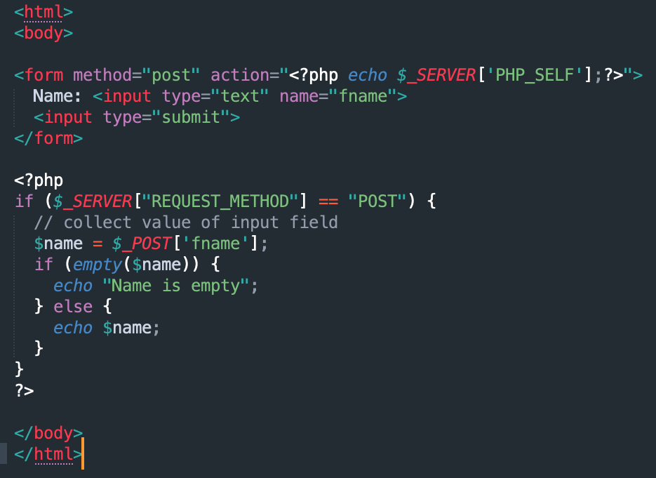

|  |
| --- |
| Run this url on your browser  localhost/dasarWeb/JS05_PHP-2/global_post.php  Submit the form and what output is produced? Observe and explain the result.  (Question No 24) |

1. $_SESSION

The $_SESSION variable is an associative array that stores user session data. This variable can be used to store a logged-in user for a specific session. It can also be used to store cart data in an online store. By default, the session lifetime in PHP is 1440 seconds or 24 minutes.

1. $_COOKIE

Similar to $_SESSION, the $_COOKIE variable can be used to store data related to the user, such as login information, cart details in an online store, and so on. The difference is that a cookie is a small file stored in the user's browser. This file is sent every time the browser makes a request to the server. The lifespan of a cookie is generally longer than that of a session.

1. $_REQUEST

Variabel $_REQUEST adalah array asosiatif yang menyimpan gabungan nilai dari variabel $_GET, $_POST, dan $_COOKIE yang kesemuanya berhubungan dengan data yang dikirim bersamaan dengan *request* user.

Create a file global_request.php, and write code as follows:

|  |
| --- |
| Run this url on your browser  localhost/dasarWeb/JS05_PHP-2/global_request.php  Submit the form and what output is produced? Observe and explain the result. And what is the difference with the global variable $_POST?  (Question No 25) |

1. $_FILES

The $_FILES variable is an associative array that stores data about files uploaded by the user in a single request using the POST or PUT method.

1. $_ENV

The $_ENV variable is an associative array that contains data about the environment in which the PHP script is running. The $_ENV variable is provided by the shell that runs the PHP script, so its values can vary depending on the operating system used.

In modern PHP frameworks like Laravel, the $_ENV variable is also used to store environment-related information, such as the database name, database password, and other values necessary for configuring the framework.

1. $GLOBALS

The $GLOBALS variable is an associative array that stores all global variables defined when the program is running. The $GLOBALS variable is a PHP superglobal used to access global variables from anywhere within a PHP script (including inside functions or methods).

Create a file global_globals.php, and write code as follows:

|  |
| --- |
| Run this url on your browser  localhost/dasarWeb/JS05_PHP-2/global_globals.php  Submit the form and what output is produced? Observe and explain the result.  (Question No 26) |

**References:**

1. Nixon, Robin. (2018). Learning PHP, MySQL, JavaScript, CSS & HTML: A Step-by-step Guide to Creating Dynamic Websites, 5th Edition. O’Reilly Media, Inc.
2. Forbes, Alan. (2012). The Joy of PHP: A Beginners’s Guide to Programming Interactive Web Applications with PHP and MySQL, 5th Edition. Plum Island Publishing